Lab 6: Phagocytosis and Osmosis in Tetrahymena
(C.U.R.E. Week 2 of 2)

Lab 6 Part 1: Phagocytosis in Tetrahymena
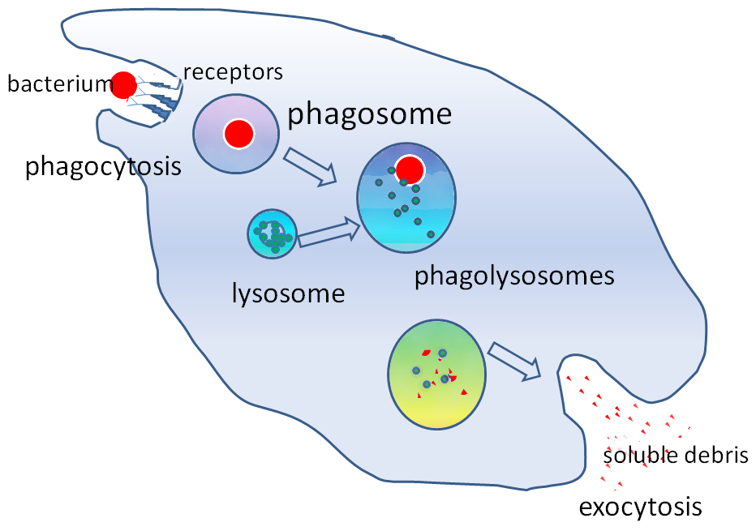
Introduction - Phagocytosis:
In order to obtain food, Tetrahymena use their cilia to pass food through their cytostome (analogous to a mouth) where the food is packaged into a food vacuole. The food within the vacuole is digested by enzymes produced by an organelle called the lysosome. The lysosome will fuse with the food vacuole, decreasing the pH and adding enzymes until the food within the vacuole is small enough to be absorbed in the cytoplasm. Undigested particles will be released into the environment through exocytosis.

Figure 1. Diagram summarizing the process of phagocytosis. Image by Graham Colm is licensed CC BY-SA 3.0.

Pre-Lab Questions - Phagocytosis:

- When Tetrahymena feeds, it consumes food in a process called __________________.

- As Tetrahymena feeds, it uses its cilia to sweep food into its _____________________.

- What are some variables that might influence food vacuole formation? Give three examples and briefly explain why each one might have an effect.

- Choose one of the variables listed above and describe an experiment you might do to determine how that affects vacuole formation.

- Why does counting multiple fields of view and calculating the average increase confidence in the accuracy of the results?

- Why do we use a log phase culture of Tetrahymena instead of a stationary phase culture? What effect do you think growth phase may have on feeding rate?

Procedure – Phagocytosis:
- Place 500 µl of Tetrahymena culture in a 2-mL microfuge tube.
- Start uptake with the addition of 500 µl 1% India ink (well-mixed); mix ink and Tetrahymena carefully/gently by triturating (pipetting up and down).
- At 2, 5, 10, 20, 30, 45, 60, and 75 minutes, take a 20 µl sample of Tetrahymena and ink and place it on a microscope slide. Quickly add 3 µl of a 5% glutaraldehyde solution to the 20 µl sample and mix with the edge of a cover slip. Place the cover slip on top.
- Count the number of vacuoles at 400x magnification in 10 different cells for each timepoint; only count cells that have at least 1 ink vacuole (note, you may not observe any for the first few minutes). Also, the cells are 3D, so focus through the cells when you count. Record your data in Table 1, below.
- Perform the following experiment at the same time/concurrently with Steps 1-4. Add 500 µl of your group’s test substance (from the Chemotaxis activity) to a separate 2-mL tube containing 500 µl of Tetrahymena culture. Wait 5 minutes before adding 500 µl 1% India ink, then proceed with the experiment as above.

NOTE: If you do not see any vacuoles after 20 minutes, please inform your instructor/have them look at your sample (it’s possible that your Tetrahymena have died from exposure to your test substance).

Standard Condition:  Table 1. Phagocytosis results. | With Test Substance (_____________________):
  Cell | 2 min | 5 min | 10 min | 20 min | 30 min | 45  min | 60  min | 75  min
  1
  2
  3
  4
  5
  6
  7
  8
  9
  10
  Avg.
  2 min | 5 min | 10 min | 20 min | 30 min | 45  min | 60  min | 75  min

- CLEAN UP: Discard all used slides in the labeled plastic bin. Save all Tetrahymena culture tubes, India ink and glutaraldehyde for the next lab section, unless empty. Dispose of gloves in regular trash bins.
- Graphing your phagocytosis data: Create a line plot for each of your 10 replicates for your standard condition and your test substance (using Excel or other software). Doing so will help you visualize and draw conclusions from your data.

Lab 6 Part 2: Osmosis in Tetrahymena

Introduction - Osmosis:

A cell’s plasma membrane acts as a semipermeable barrier, slowing the movement of most polar molecules into and out of the cell. Some water can diffuse directly across the plasma membrane, but most water crosses through special channel proteins, called aquaporins. During osmosis, water molecules pass through the membrane from the solution containing the greater concentration of water (and a lesser concentration of solutes) to the solution containing the lesser concentration of water (and a greater concentration of solutes) (Figure 2).
Imagine placing a barrier that only allows water to pass between two containers of water. If you place salt (a solute) into the water on one side of the barrier, the salt will be forced by the barrier to remain on that side. However, the concentration of water on the saltwater side is now lower than on the pure water side. Since water diffuses from higher solute concentration to lower solute concentration, water will pass through the barrier toward the saltwater side. This process is powerful enough to raise the level of fluid on the saltwater side of the barrier higher than on the pure water side (Figure 2).

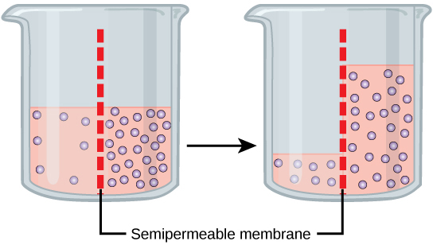
Figure 2. In osmosis, water always moves from an area of higher concentration (of water) to one of lower concentration (of water). In this system, the solute cannot pass through the selectively permeable membrane. "0307 Osmosis" by OpenStax is licensed under CC BY 4.0.

Cells have various mechanisms to deal with osmosis. For example, animal cells balance their solute concentrations to match their environments, and plant cells have strong cell walls to prevent inflowing water from bursting the cell. In humans, the excess blood sugar of a diabetic can cause osmotic stress on sensitive cells in the body. This osmotic stress can damage the cells of the retina and cause blindness or damage the kidneys. Protists, like Tetrahymena, living in freshwater lakes actively pump water out of the cell using a specialized organelle called a contractile vacuole (Figure 3).

Pre-Lab Questions - Osmosis:

- Define the following terms:

Osmosis:

Isotonic:

Hypertonic:

Hypotonic:

- What controls the direction of water movement during osmosis? Include a diagram in your answer.

- For the salt solutions, the surroundings are _________ to the cytoplasm and the cell is ___________ to the surroundings (hypertonic, isotonic, or hypotonic).

- What molecules provide the energy necessary for contractile vacuole activity? Why might a shortage of water make it impossible for these molecules to release the energy they store?

- List two ways in which humans maintain a homeostatic water balance.

Procedure – Osmosis:

This activity will require you to use the 40x (highest) objective on your microscope (so, you will need to prepare wet mounts with cover slips). Also, healthy Tetrahymena swim very fast, so you’ll need to use some Detain/methylcellulose (a thick, viscous solution) to slow them down enough to observe their contractile vacuoles.

Finding contractile vacuoles
- Using a p20 micropipette, transfer 10 µL of Tetrahymena culture to a slide.
- Using a new pipette tip, add 10 µL of Detain to your drop of cells; mix using your pipette tip.
- Place a cover slip over your sample and view your slide (start with the 4x lens).
- Look for a slow-moving Tetrahymena near the middle of your field of view. Without losing sight of your cell, switch to your 10x lens, re-focus if needed using the fine focus knob, and finally, switch to your 40x lens. If you look closely, you should be able to see a round, bright spot at the posterior end of the cell that expands and shrinks after a little while; this is a contractile vacuole.
Figure 3. Photo displaying contractile vacuole in Tetrahymena at 400x magnification.

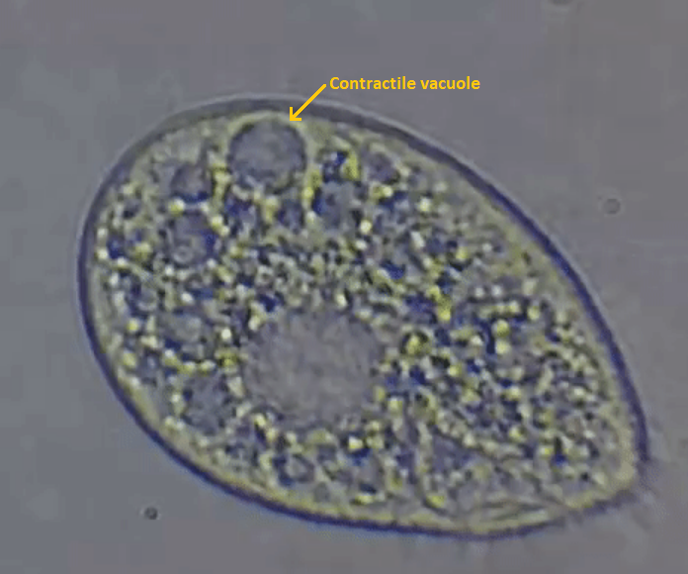

Determining contraction rate: to get repeatable results, you need to be consistent in the way you measure a contraction cycle (i.e., start timing your series of contractions when the vacuole finishes expanding, OR when it contracts – whichever you choose, be consistent with all cells that you observe). To time contractions, one person in your group should be observing cells while another person operates a stopwatch.

- Keep the same cell in your field of view. As soon as you see its vacuole contract (or finish expanding), inform your partner to start timing, and count four more contraction cycles (again, be consistent when determining the ‘end’ of a cycle). Once you have observed a total of four contractions, inform your partner to stop timing, and record your results in seconds in Table 2 below. Note: cells may have multiple vacuoles, so it’s important to look for contractions in the same part of the cell.
- (Optional) Observe/count contraction cycles in two other slow-moving cells, preferably in a different area of the slide. You may observe some variation in contraction rate between cells, however it should be similar to the first cell you observed. NOTE: this data can be used for your ‘NEFF’ samples/replicates in Table 3.

Table 2: Practice observing/timing contractions.

Time, 4 contractions (sec)
Cell #1

(Optional) | Time, 4 contractions (sec)
Cell #2
Cell #3

Observing the effects of various solutions on contraction rate

First, you must set up a “control” sample, NEFF solution, to observe vacuole contractions under isotonic conditions – this was performed in the previous steps.

- Get a glass slide and pipet 10 µL of Detain onto the slide.
- Using a new tip, add 10 µL of NEFF media to the slide right next to the first drop.
- Change the tip again and add 10 µL of culture to the slide right next to the first two drops. Stir the three drops together with your pipette tip. Apply a cover slip.
- Put your slide under the microscope and find a centrally located, slow-moving cell. Using the same process to find a cell/locate its contractile vacuole, measure the amount of time needed for four contractions. Rotate tasks with your group and count at least three different cells. Record your data in Table 3 below.
- Repeat steps 1-4, but instead of using 10 µL of NEFF, add 10 µL of deionized (DI) water. Record your data in Table 2.
- Repeat steps 1-4, but instead of using 10 µL of DI water, add 10 µL of your test substance (from the Chemotaxis activity). Record your data. NOTE: if your extract has fallen out of solution, gently shake your tube to resuspend it as much as possible.
- If you have time, repeat steps 1-4, but instead of using 10 µL of test substance, add 10 µL of 50 mM NaCl. Record your data.

Table 3: Determining average contraction rates of cells in different solutions.

 | Neff | DI water | Test substance | 50 mM NaCl
Replicate 1
Replicate 2
Replicate 3
Average time
Average rate (cycles per minute)

- CLEAN UP: Discard all used slides in the labeled plastic bin. Save all tubes and solutions for the next lab section. Your extract tubes need to be properly disposed of; label them (clearly) with the name of your substance and return them to your class’ tube rack with Parafilm.

Post-Lab Questions (Phagocytosis and Osmosis)

- How similar were the times for each of the cells that you and your partner counted?

- How does counting several cells and averaging give you more confidence that your data are accurate?

- Which mixture showed:
  - The most frequent contractions? ______________________

  - The longest time for four contractions? ______________________
  - The shortest rate of contraction? ______________________

- What effect did the salt solutions have on the appearance of Tetrahymena? What does this tell you about the direction water has moved (i.e., into or out of the cell)?

- At the highest salt concentration, did you see contractile vacuoles? Were they contracting?

- What happened to the number of food vacuoles per cell as the incubation time increased? What does this represent occurring in the cell?

- Reflect on the Osmosis results for your test substance. Was your hypothesis supported or rejected, and why? How would you revise your hypothesis based on your results?

- Reflect on the Phagocytosis results for your test substance. Was your hypothesis supported or rejected, and why? How would you revise your hypothesis based on your results?

